How to create Unit Tests using the VI Test framework
The VI Test framework enables you to unit test your VIs quickly and easily. In order to utilize the test framework, you need to build tests – this document describes this process.

Test requirements:
1) Exist as methods within a TestCase child (descendant) class
2) Must be named with testXXXX convention where XXXX is the test name (except for the optional “setUp” and “tearDown” methods). For example: testSetName would be a test of the ‘SetName’ method.
3) Must have the following structure:
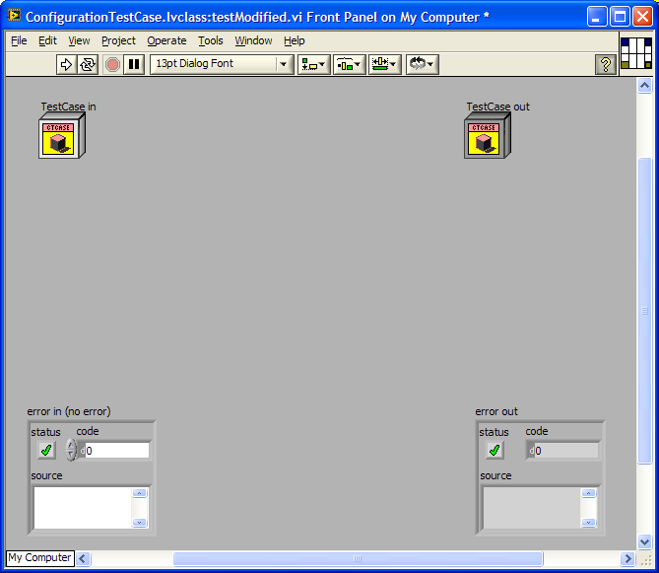

Make sure that the Classes (In/Out) are NOT Dynamic dispatch but are Required. Make sure that the Class is a TestCase ancestor. Make sure controls are names as shown above.

Creating Tests:
Tests should be simple, easy to follow and have one purpose. Tests should not have dependencies on other tests.
Test Harness:
Each TestCase has a Test Harness. The Test Harness ensures that the tests are isolated from each other so that tests independence is preserved. The Test Harness consists of 2 VIs: setup.vi and tearDown.vi. These VIs are run for each test method is executed. The setUp VI is run prior to the test. The tearDown VI is run after the test. These VIs can be used to perform code that is common to all test methods such as creating and destroying objects that are used by tests.
The Test Harness must have the following connector pane:
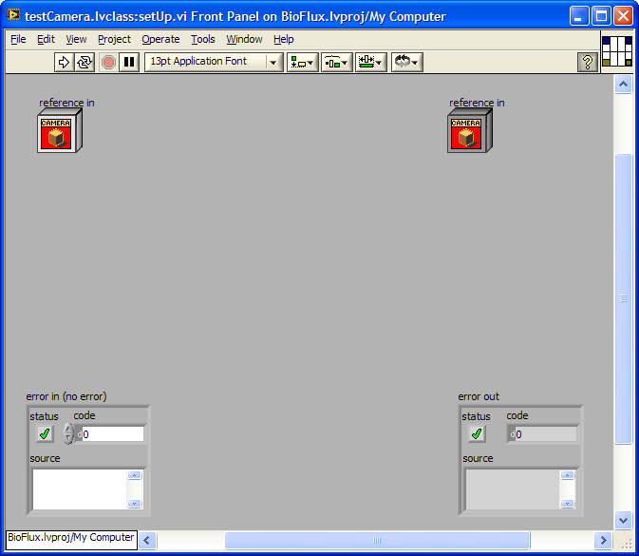

Passing/Failing Tests
Via Error Cluster:
The simplest way to make a test fail is to generate an error in a test. This will automatically make the test fail and requires no additional framework VIs.
Via Framework:
There are several test evaluation VIs in the TestCase base class that can be used to evaluate test results:
Fail
Failif
FailUnless
FailUnlessError
FailUnlessEqual
FailIfEqual
These methods have additional power that you can take advantage of… primarily they have a description field that will be visible in the results and some have features such as a delta for comparison in ranges. Errors will still get propagated as failures even if you use these VIs.

